Fee SCHEDULE 2021– Year 11/12

Name of the Student: ………………………………

Please find the itemised list of Essential Student Learning Items and Optional Items for your child. Lyndale Secondary College also continues to welcome your voluntary contributions for 2021

Please complete this form and return to the school by 15/12/2020 so the school can prepare accordingly.

Essential Student Learning Items
Below is a list of items and activities which are essential for your child to learn the standard curriculum. You may choose to purchase these items through the school or provide your own. Please indicate which items you would like to purchase through the school on the table below:

If you child is doing an elective subject/ a VET course in 2021, please see the last pages for charges.

Essential Student Learning Items | Amount
School Diary  Student ID  Initial print credits related to curriculum activities  School Sports Carnival programs(Athletic/Swimming/other) (CSEF applicable)  Material charges for VCE subjects(non elective)  Total  Material fees for elective subject/s (See page 4) | $10  $10  $20  $40  $25  $105  $ ……..
VET material fee (See page 5) | $...........
TOTAL Essential Items | $ ……..

Optional Items
Lyndale Secondary College offers a range of optional items and activities that are additional to the delivery of the standard curriculum. These items and activities are designed to broaden the school experience for your child. If you would like to purchase an item or activity for your child, please indicate on the table below.

Optional Item | Amount
Magazines/Newspaper/Library material subscription  Co –Curricular activities (sport levies for State Sport Affiliations & inter school sport)  Art festival and other year level activities  Total | $5  $15  $10  $..........
Total of Essential and Optional Items | $ ………

Other Optional Activities | Amount
1. Year11 Camp- No payment plans. CSEF can be applied only if parents/guardian have Centre link card valid until Dec ,2021  Camp Deposit (Due date will be notified in 2021)  Camp balance (Due date will be notified in 2021)  2. Optional camps and excursions as scheduled throughout 2021. The cost of these excursions will be advised throughout the year  3.Music Program (Please ensure Instrumental Music and Voice Levies form is provided) | $120 (may change)  $200 (may change)  To be advised  As in the form

Voluntary Contributions
Lyndale SC continues to welcome your voluntary contributions to support our school.

You can make a general voluntary contribution that goes towards all of our school’s important priorities for 2021 as well as providing additional activities and services for all students.
Alternatively, you can make a voluntary contribution to any of the specific priorities outlined in the table below:

Voluntary Contribution | Tax deductible? | Suggested Voluntary Contribution per student |  |  | Amount
Compass usage for teaching and learning in the classroom No $60 $ ……….
Online Assessment Tools such as Career/Acer No $15 $ ……….
Classroom materials (photocopying/printing worksheet, No $10 $ ………..
booklets, art works, exams)
School sport equipment No $20 $ ………
Library books No $20 $ ……..
Total of non-tax deductible voluntary contribution $ ………..
Building Fund donation(donation over $2 are tax deductible) per family | Yes | $10 - $20 | $20- $50 | $50- above | $ ………..
School council has established tax-deductible gift recipient status with the Australian Taxation Office for the Building Fund

Total voluntary contribution |  |  |  |  | $.........

Your child will not be disadvantaged if you do not make a voluntary contribution. All records of voluntary contributions are kept confidential as well as your decision about whether to make a contribution or not.

Please contact Bonnie Ly at Lyndale SC on 9795 2366, if you have a query re school fees.

Parent Payment Charges
Essential Student Learning Items Amount $_______
Optional Items Amount $_______
Voluntary financial contribution Amount $ _______
TOTAL Amount $_______

Payment SCHEDULE 2021– Year 11/12

Student Name: ________________________________________ Home Group: _____________
Parent/Guardian Name: _____________________________Phone Number: _________

Parent Payment Charges as in the previous page
Total amount to be paid $ ______
Notes (office use only):

Payment Methods: Please mark the payment option.
Option A: CASH

Option B: DIRECT DEPOSIT BSB: 313 140 ACC: 12036006

Lyndale Secondary College
Please ensure you enter your child/s first and last name in the reference)

Option C CompassPay (pay via Compass)

Option D: BPAY – BILLER CODE: 87361 FAMILY ID CODE: __________

(Please email lyndale.sc@education.vic.gov.au to advise what charges are being paid, otherwise payment will be allocated against the oldest charge.

Option E: PAYMENT PLANS
Paying by instalments can be arranged through Centrepay (application form to be completed with a valid Centrelink card) or ‘Payment Plan’ set up on Compass. Please contact the office for more information regarding Payment Plans on 9795 2366.

Option F: CREDIT CARD PAYMENT

Card Number:

CCV
/
Expiry Date:

Name as appears on card (PLEASE PRINT): _______________________________________________________

Cardholder’s signature: _______________________________Amount being paid: __________

Student Name: …………………………………... Home Group: …….

VCE ELECTIVE SUBJECT MATERIAL FEES 2021

Elective Subject | Cost | Tick the box
Art Y 11 | $60
Food Studies Y11 | $140
Art Y 12 | $60

VET COURSE MATERIAL FEES - Lyndale SC 2021

VET Y11 Cert ii Kitchen Operation | $630
VET Y 11 Cert iii Sport & Rec | $450
VET Y 12 Cert ii Kitchen Operation  (Only for new enrolments in 2021.The students enrolled in 2020 and paid fully not required to pay ) | $350

Student Name: …………………………….

VET COURSE MATERIAL FEES (EXTERNAL) 2021

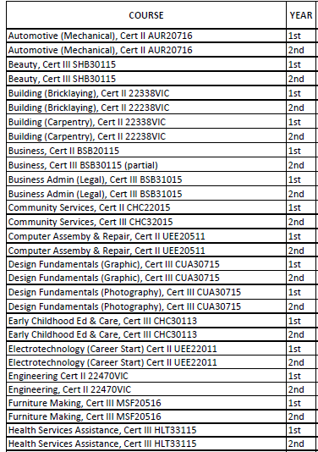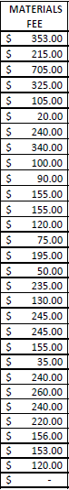

Student Name: ……………….. Year level: ……

